**Android device management**

**Traditional way**

The traditional way of EMM development is based on the below architecture

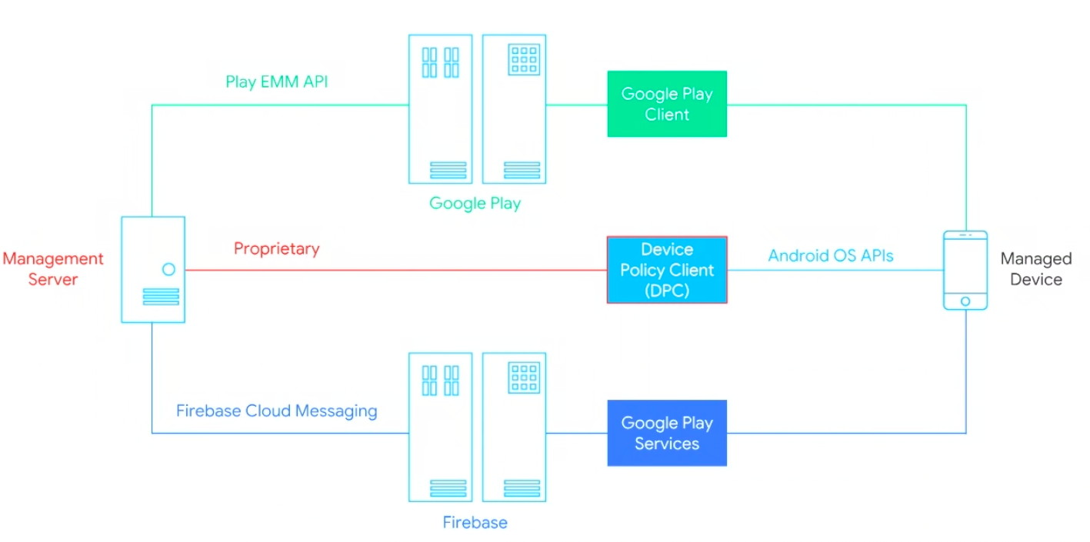

**How it works?**

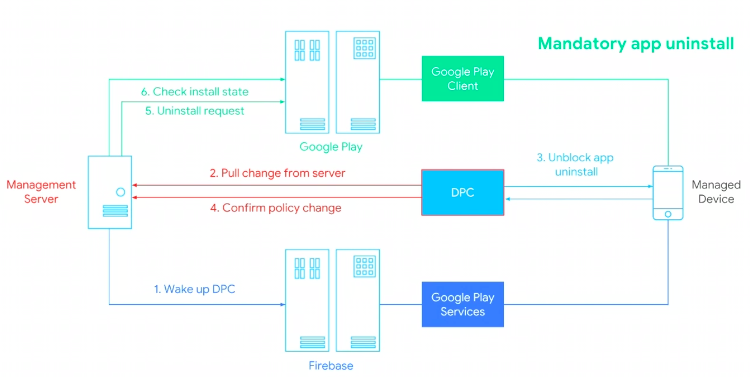

**Modern Way**

